Chapter 4, Solution 70

Determine the maximum power delivered to the variable resistor R shown in the circuit of Fig. 4.136.

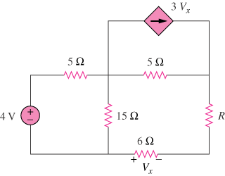

Figure 4.136
For Prob. 4.70.

Solution

We find the Thevenin equivalent across the 10-ohm resistor. To find V_{Th}, consider the circuit below.

3V_{x}

5 5

+
+

4V 15 V_{Th}
- 6
–

+ V_{x -}

From the figure,
To find R_{eq,} consider the circuit below:

3V_{x}

5 5
V₁

+

I_{sc}
4V 15
– 6

+ V_{x} -

At node 1,

[(V₁–V_{x})/15] + [(V₁–(4+V_{x}))/5] + [(V₁–0)/5] + 3V_{x} = 0 or
0.4667V₁ + 2.733V_{x} = 0.8 (1)

At node x,

[(V_{x}–0)/6] + [((V_{x}+4)–V₁)/5] + [(V_{x}–V₁)/15] = 0 or
–(0.2667)V₁ + 0.4333V_{x} = –0.8 (2)

Adding (1) and (2) together lead to,

(0.4667–0.2667)V₁ + (2.733+0.4333)V_{x} = 0 or V₁ = –(3.166/0.2)V_{x} = –15.83V_{x}

Now we can put this into (1) and we get,

0.4667(–15.83V_{x}) + 2.733V_{x} = 0.8 = (–7.388+2.733)V_{x} = –4.655V_{x} or V_{x} = –0.17186 V.

I_{sc} = –V_{x}/6 = 0.02864 and R_{eq} = 3/(0.02864) = 104.75 Ω

An alternate way to find R_{eq} is replace I_{sc} with a 1 amp current source flowing up and setting the 4 volts source to zero. We then find the voltage across the 1 amp current source which is equal to R_{eq}. First we note that V_{x} = 6 volts ;
V₁ = 6+3.75 = –9.75; V₂ = 19x5 + V₁ = 95+9.75 = 104.75 or R_{eq} = 104.75 Ω.

Clearly setting the load resistance to 104.75 Ω means that the circuit will deliver maximum power to it. Therefore,

p_{max} = [3/(2x104.75)]²x104.75 = 21.48 mW

